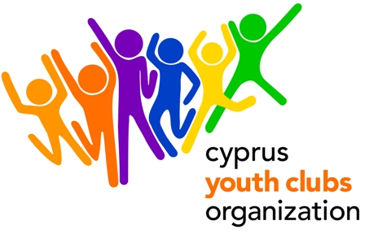
Tradition P2P: From Past 2 Present

PROJECT OUTLINE
- Project title: Tradition P2P: From Past 2 Present
- Organization: Cyprus Youth Clubs Organization (CYCO)
- Main theme for the project: Tradition, different cultures, similarities and differences, how has tradition affected our modern way of life, how can we learn through tradition.
- Number of participants: We encourage organizations to participate with 4 people each and 1 leader (gender balanced group).
- Age range for participants: 13- 18 (20% can be over 18). No age limit for the Leaders
- Project type: Youth in Action (Action 1 – Youth for Europe/ Sub-Action 1.1 Youth Exchanges)
- Organization’s Country: Cyprus
- Place: Cyprus
- The project starts: 16/04/2012(arrival date)
- The project ends: 22/04/2012 (departure date)
- Deadline for applications : 22/10/2011
- Contact person: Giorgos Kafkalias
- E-mail: giorgos.kafkalias@cyco.org.cy
- Tel.: +35722323260
- Fax: +35722321979
- Summary of the project: "Tradition P2P: From Past 2 Present"is a youth exchange concerning young people aged 13-18(20% can be over 18). The aim is for young people to get acquainted, familiarized and assimilate different traditions and cultures of different Countries. What is Tradition? What does it consist? How can tradition teach us aspects of society today? How can young people create connections through analyzing and learning about traditional dances, songs, through analyzing myths, legends and stories drawn from the tradition of each country and what the similarities and differences between the cultures are? The tradition of each country as a tool for better communication and understanding and mutual respect. Except of the joint program, each day one of the participating countries is going to have the joy of presenting aspects of its traditions. Whatever they feel that they want to share. Inter-active games creating posters, and many more surprises that nobody will expect, will give a touch of fun in this exchange. It is an exchange of learning, acquaintances, with meaningful content for young people. We all know how hard is to take away young people’s attention from technology and laptops and PC’s etc. This is a chance and a challenge to raise awareness and interest of young people according to Tradition that in other circumstances it would be really hard to get the attention.

- How to participate: Send us a short description of your organization and the link to your website (if available). After you fill in the Part 3 send the scanned version to Giorgos Kafkalias giorgos.kafkalias@cyco.org.cy or fax it to +357 22321979 and mail the original to:

GIORGOS KAFKALIAS
CYPRUS YOUTH CLUBS ORGANIZATION
Platia Iroon 1, Ag. Mamas, Lakatamia, 2330, CUPRUS
CYPRUS

- Financial aspects: Participants will be reimbursed for the 70% of the travel cost on display of their boarding passes. Reimbursement of travel costs will only be done upon full attendance in the activity and presentation of the original tickets with boarding passes and receipt/invoices.
Food and accommodation is paid. Participants will be required to pay a participation fee of €30.
- Safety & Insurance: We will require copies of the travel insurances before travelling to Cyprus.

